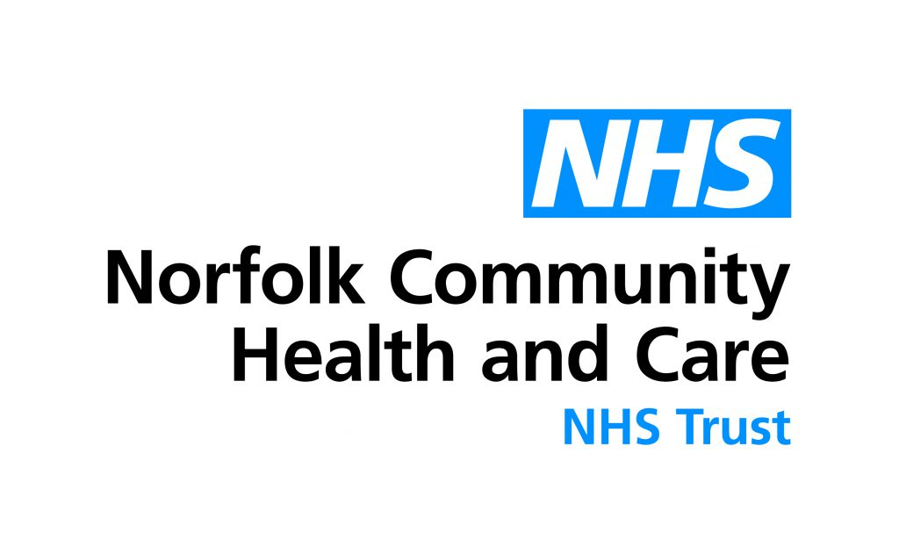
Volunteer Application Form
Priscilla Bacon lodge

Thank you for your interest in volunteering at Priscilla Bacon lodge with Norfolk Community Health and Care (NCH&C). The Volunteer service at Priscilla Bacon Lodge has been established for over 40 years and is provided by Norfolk Community Health and Care. This service is managed by the Volunteer Co-ordinator.

The Norfolk Community Health and Care NHS Trust Volunteer Service outside of PBL is provided in partnership with Voluntary Norfolk. The Voluntary Norfolk team deliver the Volunteer Service for Norfolk Community Health and Care in all NCHC sites other than PBL.

Please complete the information requested in the following application form and return either by email PriscillaBaconVolunteers@nchc.nhs.uk or by post to Catherine Wilson, Priscilla Bacon Lodge Century Place Colney Norwich NR4 7YA. 01603 776644.

Eligibility to volunteer
For volunteering roles with us you must be:

- A UK citizen/ An EU citizen/ A refugee or asylum seeker/ An overseas visitor with an appropriate visa
- You must be over 16.
- Be willing to volunteer on a regular, usually weekly basis, for a consecutive six-month period.

The next steps:

Informal interview and background checks
Once we have received your completed application, if we have a suitable vacancy we will arrange for an informal interview and will contact your referees to request references. We will then carry out your DBS (police background) check.

Induction training
Once your reference request and DBS check have been completed and are considered satisfactory, we will arrange your one-day trust induction at which you will be introduced to Norfolk Community Health and Care NHS Trust and includes essential training and information. We will also enrol you for any on-line training requirements.

If the role you choose is of a specialist nature, additional training may be required.

Getting started
Once you have completed your trust induction your site induction will be arranged at which you will be officially welcomed to the Trust and Priscilla Bacon Lodge, and you will be provided with an ID badge and uniform to wear whilst on duty as a volunteer.

Volunteer Application Form

Section A - Your Personal Details

Preferred Volunteer Role:

Surname: | First Name:  Preferred Name:
Telephone Number Home Mobile
Home Address:

Email address:
Age Band (please tick): 17 18+

*Emergency contact details: (name and contact number)

Do you consider yourself to have a disability or support needs which are relevant to your ability to undertake the volunteer role?  The Equality Act 2010 defines disability as “a physical or mental impairment that has a substantial and long-term adverse effect on a person’s ability to undertake normal day-to-day activities”. |  | Yes  No
If yes, please provide additional information as you consider appropriate, including how we may be able to assist you in your volunteering role:

Section B - Your experience

What has motivated you to join as a volunteer with Norfolk Community Health and Care?
Make new friends |  | Help with employment
Develop/refresh skills |  | Make use of spare time
Helping others |  | Referred by health professional
Gain confidence |  | Other (please describe)

How did you hear about us? (e.g., family, friend, advert)

Present/previous occupation(s):

Have you any previous experience of volunteering? If so, please give details.

What skills/qualities would you bring to a volunteering role with Norfolk Community Health and Care?

What are your hobbies and interests?

Section C - Your availability (please tick when you could be available)

 | Mon | Tues | Wed | Thurs | Fri | Sat | Sun

Morning

Afternoon

Evening

Please outline how much time you would like to commit to volunteering with Norfolk Community Health and Care? E.g., weekly, fortnightly

Please confirm that you will be available to volunteer regularly for six consecutive months, once you have started your placement.

Yes No

Section D - Any dislikes

Are there any voluntary activities that you would not wish to undertake? Please give details.

Section E - References

Please give details of two people (not relatives) who we can approach for references.

Reference 1 Reference 2

Name Name

Relationship Relationship

to you to you

Occupation Occupation

Address Address

Postcode
Postcode

Telephone Telephone
no. no.

Email Email

Section F – Right to volunteer in the UK.

There are restrictions on people from outside the UK volunteering and this varies depending on the type of visa they have. It is therefore important that before volunteering, people from outside the UK check that they are allowed to do so. The individual volunteer is responsible for checking that their documentation allows them to volunteer.

Do you have the right to volunteer in the UK and do you have documentary evidence to support this?

Yes

No

Section G - Data Protection

How is information used by NCH&C?
We need to know your personal data in order to work with you. Under the General Data Protection Regulation (GDPR) and the Data Protection Act 2018 we will be lawfully using your information to assist in arrangements for you to be able to volunteer with us.

How long do we hold your information for?
NCH&C hold records in accordance with the Records Management Code of Practice for Health and Social Care 2016. For more information see Appendix 3 of the Code contains the detailed retention schedules and sets out the minimum time that records should be retained. (The code can be found here; https://digital.nhs.uk/data-and-information/looking-after-information/data-security-and-information-governance/codes-of-practice-for-handling-information-in-health-and-care/records-management-code-of-practice-for-health-and-social-care-2016)

Data subject (you) rights
The General Data Protection Regulation (2016) gives you the general right to apply to see or to be given a copy of personal data held about you. You also have the right to request rectification or erasure of personal data, to restrict or object to the processing of information about yourself. If you wish to do this, contact the Information Governance team on 01603 785879 or email IG@nchc.nhs.uk

What should you do if your personal information changes?
Please let us know as soon as any of your details change, this is especially important for changes or address or contact details (such as your mobile phone number). We may from time to time ask you to confirm that the information we currently hold is accurate and up to date.

Data Protection Officer, (DPO)
NCH&C is a public authority and therefore is legally required to appoint a DPO. The DPO assists with monitoring internal compliance, informing and advising on data protection obligations, provide advice regarding Data Protection Impact Assessments (DPIAs) and acting as a contact point for data subjects and the supervisory authority. Their contact details are:

Matthew Poole Data Protection Officer
Norfolk Community Health and Care
Norwich Community Hospital Bowthorpe Road
NorwichNR2 3TU
Telephone: 01603 272619
Email: DPO@nchc.nhs.uk

Section H - Contacting you

At Norfolk Community Health and Care NHS Trust Volunteer Service we take your privacy seriously and will only use your personal information to contact you about issues relating to your volunteering, for example requests for Volunteer support or training opportunities.

If you consent to us contacting, you for this purpose please tick to say which methods you are happy for us to use to contact you:

Email

Post

SMS/Text

Phone call

From time to time we would like to contact you with details of updates about Norfolk Community Health and Care, for example changes to services or fundraising events. Would like to receive these additional updates:

Yes

No

Section I – Declaration

Vaccination Status

Please state how many COVID Vaccinations you have had, and the dates received. Proof of Vaccination status will need to be seen prior to starting. Please note that NHS vaccination cards cannot be used as proof of vaccination status.

Vaccination status may determine what roles you are able to carry out.

I give my consent for Norfolk Community Health and Care NHS Trust to hold and process personal information about me, in accordance with the described requirements.

I confirm that the above statements are true and correct and understand that any misrepresentation will invalidate this form. I am prepared to undergo a medical examination if requested.
Signature: | Date:

